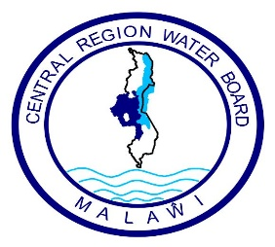

**Central Region Water Board**

**Request for Quotations (RFQ) for SALIMA DISTRICT HOSPITAL MAINTENANCE WORKS**

1. The Central Region Water Board is inviting eligible bidders to carry out Maintenance Works at Salima District Hospital through Request for quotations.
2. Interested eligible Suppliers must be registered with M.R.A, P.P.D.A and M.S.M.E and will be required to complete a set of Request for Quotations which can be downloaded from Central Region Water Board website
3. Sealed Bids must be delivered and deposited at CRWB head office **on or before 14.00 hours on Friday 25th August 2023 clearly marked with Request for Quotation for Maintenance Works at Salima District Hospital** as indicated above**.**
4. Bids will be opened at **Central Region Water Board** on **Friday 25th August 2023** at **14.00 hours’ local time.** Late bids shall be rejected.
5. Central Region Water Board reserves the right to reject any or all bids and is not bound to accept the lowest or any other bidder.
6. Addresses for:
7. Clarifications**:**

**Attention: Mr. Time Nyalapa – Acting Procurement and Disposal Manager**

**Central Region Water Board Offices**

**Area 4, Murray Road**

**Opposite Immigration Offices**

**Private Bag 59**

**Lilongwe**

**Malawi**

**Phone No: +265 (0) 310002128**

**Cellphones: 0888 903 621 / 0999 203 621**

**Email:** [**crwb@crwb.org.mw**](mailto:crwb@crwb.org.mw) **/** [**tnyalapa@crwb.org.mw**](mailto:tnyalapa@crwb.org.mw)

1. **Submissions**

**Attention: Engineer John Makwenda – Chief Executive Officer**

**Central Region Water Board Offices**

**Area 4, Murray Road**

**Opposite Immigration Offices**

**Private Bag 59**

**Lilongwe**

**Malawi**

**Phone No: +265 (0)310002128**

**Cellphones: 0881 707 535 / 0996 707 535**

**Email:** [**crwb@crwb.org.mw**](mailto:crwb@crwb.org.mw) **/** [**jmakwenda@crwb.org.mw**](mailto:jmakwenda@crwb.org.mw)